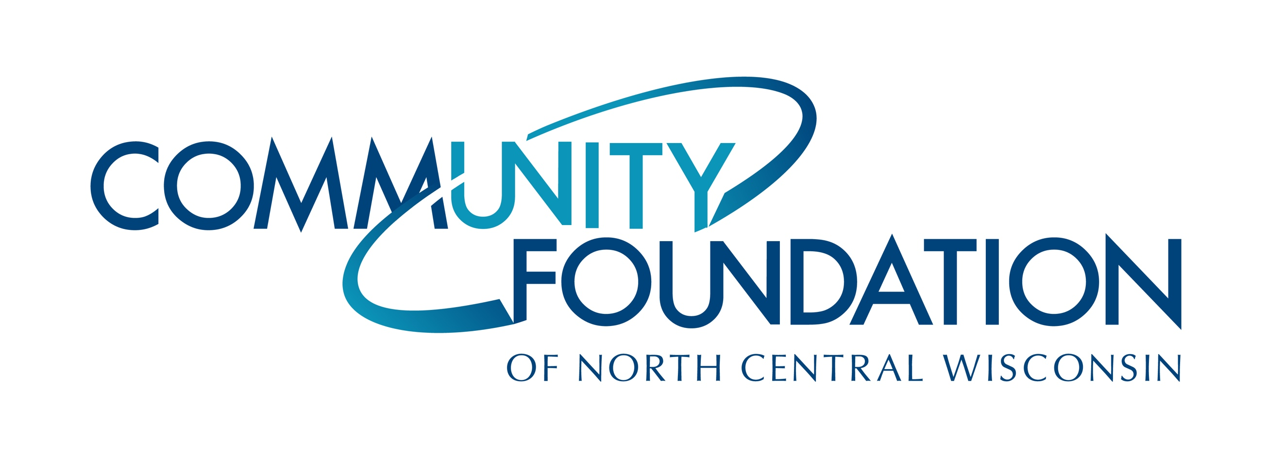
CONTACT INFORMATION:
Community Foundation of North Central Wisconsin
Jenna Weix, Director of Marketing
jenna@cfoncw.org ⎪ 715.845.9555

RELEASE DATE:
September 22, 2020

COMMUNITY FOUNDATION OF NORTH CENTRAL WISCONSIN NAMES TIM PARKER PRESIDENT/CEO

[WAUSAU, WI, September, 2020] — The Community Foundation of North Central Wisconsin’s board of directors is pleased to announce that it has named Tim Parker as its new President/CEO effective October 2020. Parker, being an energetic entrepreneur and global business leader, brings a wealth of leadership experience and a passion for positive change within local communities. He succeeds Jean Tehan who retired on August 31.

“Our board of directors is thrilled to introduce a leader of Tim’s caliber into our community to guide the Community Foundation,” said board chair, Chris Pfender. “Tim possesses the qualifications and expertise to grow the Community Foundation into an even greater, more successful, organization to create a lasting impact on our area.”

Parker comes to the Foundation from his role as president of Michigan Capital Network, an investment organization committed to growing strong entrepreneurs and companies in Michigan and the Midwest region. Prior to Michigan Capital Network, Parker was the founder of a global export, trading, and consulting startup with the goal of increasing trade between Michigan and Asian markets. During his seven years as an entrepreneur, he obtained exclusive rights to Asia for 15 U.S. brands, representing more than 120 SKU’s and establishing relationships with major retailers in China, Hong Kong, Taiwan, the Philippines, Japan, South Korea, and others. He also spent 17 years at Bissell, Inc., including eight years as its global vice president of research and development. During college and for a couple of years after, Parker worked as a launch engineer for a tier-one automotive supplier, Prince Corporation.

Parker holds a B.S. degree in Manufacturing Administration (’90) and a M.B.A. (’00) from Western Michigan University.

“I could not be more grateful to accept the position as President/CEO to this well-established and well-loved organization that consists of an extremely talented team and long history of dedicated donors and nonprofit partners,” says Parker. “My goal in leading this organization is to build on the achievements of the past 33 years. The Community Foundation will not only maintain its high level of standards in philanthropy but will continue to expand upon our impact in north central Wisconsin.”

Parker’s appointment concludes a three-month national search process completed by a search committee, led by Amy Plier. “It was evident to the committee almost immediately that Tim’s ability to perform at the highest level along with his business acumen would align very well with the work of the Community Foundation,” Plier says. “As we look to the future, we’re confident that Tim is the right person to lead the Community Foundation and carry on the long legacy of providing the highest level of service and support to Foundation donors and the nonprofit sector.”

Parker will assume the role of President/CEO on October 5, 2020. Please join the board of directors of CFONCW in welcoming Tim Parker to our community.

###

About the Community Foundation of North Central Wisconsin:
Since 1987, the Community Foundation of North Central Wisconsin has been connecting the passions of philanthropists with the purposes of nonprofits for local community impact. With over 32 years serving the north central Wisconsin region, the Community Foundation leads and inspires philanthropy to enhance the quality of life for generations to come. The Community Foundation has over $67 million in current assets and prudently manages 431 funds. Through its commitment to excellence in donor investment, the Foundation received $6.3 million from donors in 2019 and distributed more than $5.8 million that same year to support nonprofits throughout our area.

