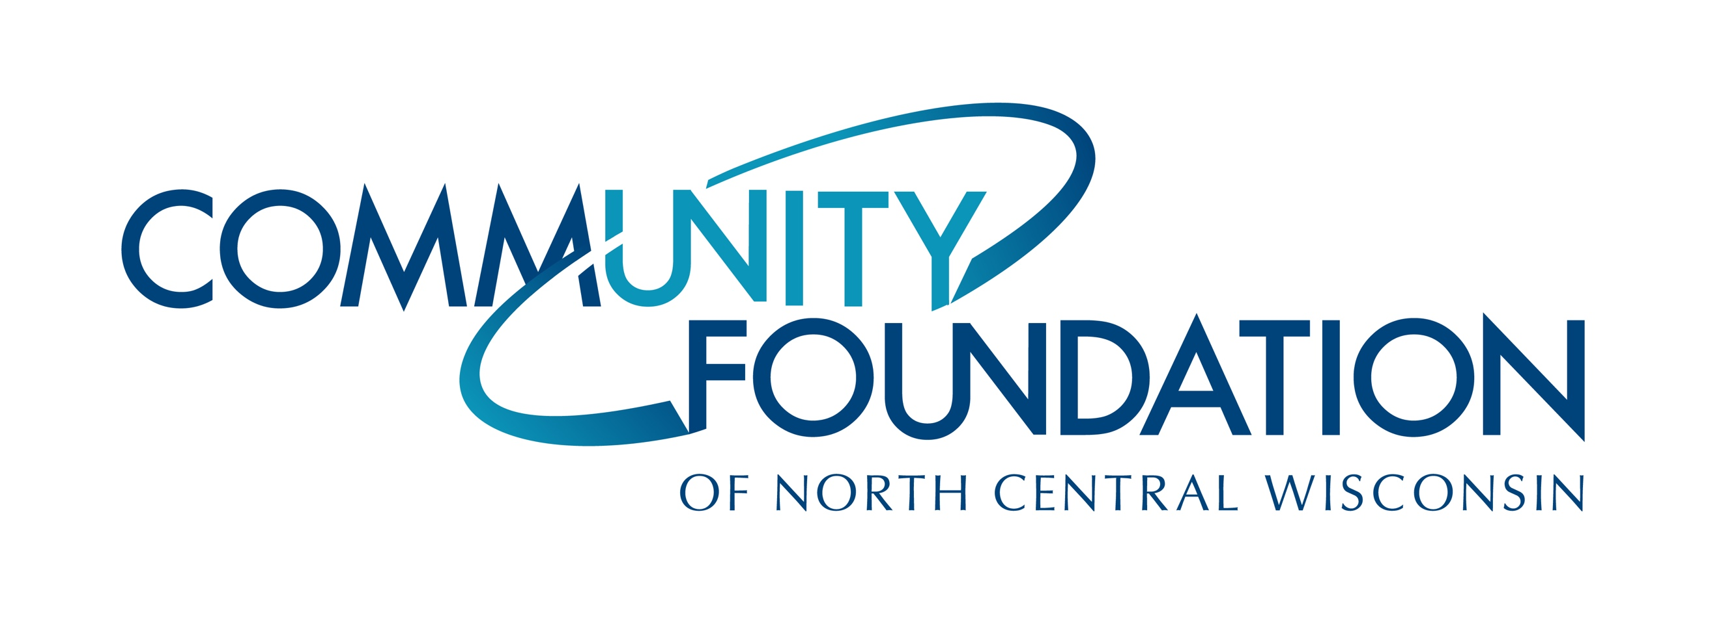
CONTACT INFORMATION:
Community Foundation of North Central Wisconsin
Sue Nelson | Program Officer
715.845.9555
sue@cfoncw.org

RELEASE DATE:
December 17, 2020

COMMUNITY FOUNDATION AWARDS MORE THAN $555,000 IN
COMMUNITY ENHANCEMENT GRANTS IN 2020

[WAUSAU, WI, December 2020] — The Community Foundation of North Central Wisconsin announced that 35 charitable causes have received Community Enhancement Grants totaling more than $550,000 in the year 2020.

Community Enhancement Grants address the tangible needs of nonprofit organizations, as well as new initiatives, that create a vibrant and livable community for all. These grants provide support for the arts, education, health, human services, and resource preservation – enhancing every area of life for people throughout Marathon County.

“Our board is dedicated to being good stewards of the contributions that have been entrusted to us, and we couldn’t be more proud of the grants that we gave in 2020. Being forward focused, we know these grants are going to organizations and projects that are enhancing our area each day” states Ann Werth chair of the Community Foundation’s Distributions Committee.

The next Community Enhancement Grant deadline is March 1, 2021. Grants range in size from $1,000 to $100,000 depending on the scope of the proposal. Applicants are strongly encouraged to speak with Foundation staff before applying. Visit here for more details.

###

About the Community Foundation of North Central Wisconsin:
Since 1987, the Community Foundation of North Central Wisconsin has been connecting the passions of philanthropists with the purposes of nonprofits for local community impact. With over 33 years serving the north central Wisconsin region, the Community Foundation leads and inspires philanthropy to enhance the quality of life for generations to come. The Community Foundation has over $67 million in current assets and prudently manages 431 funds. Through its commitment to excellence in donor investment, the Foundation received $6.3 million from donors in 2019 and distributed more than $5.8 million that same year to support nonprofits throughout our area.

Community Enhancement Grants Awarded 2020

Organization | Purpose | Grant Amount
Achieve Center | Sound Technology: Audiometer | $ 1,126.00
Aspirus Health Foundation | Food is Medicine | $ 3,626.00
Athens Advancement and Agricultural Association | Athens Fair Grounds Electrical Safety Upgrade | $ 10,000.00
Beyond Pencils & Crayons Grants | Beyond Pencils & Crayons Grants 2020-21 | $ 25,000.00
Blessings in a Backpack DC Everest - Wausau | Bins for Distributing Food Backpacks | $ 2,160.00
Boys & Girls Club of the Wausau Area | Boys & Girls Club Walk-In Cooler | $ 6,296.00
Center for the Visual Arts | Lumberjacks Love Computers, Especially Logging In! | $ 5,000.00
Central Wisconsin Off Road Cycling Coalition | Nine Mile County Forest Mountain Bike Trail Improvements | $ 15,000.00
Central Wisconsin Water Walkers | Community Dock Upgrade | $ 10,000.00
Children's Imaginarium | Children's Museum Capital Campaign | $ 15,000.00
Community Arts Grants | Community Arts Grants 2020 | $ 25,000.00
Community Partners Campus | New Nonprofit Facility Capital Campaign | $ 100,000.00
CWIMMA/NCWWDB | CWIMMA Milestone Program | $ 7,500.00
Forest Park Village | Onward and UP-ward | $ 15,000.00
GiGi's Playhouse Wausau | Believe In Our Build | $ 25,000.00
Hope Life Center | Technology Upgrades | $ 4,300.00
Keep Area Teens Safe (KATS) | KATS Initial Start-up (Phases I & II) | $ 25,000.00
LuCille Tack Center for the Arts | Art Gallery Refresh at LuCille Tack Center for the Arts (LTCA) | $ 5,650.00
Marathon County Literacy Council, Inc. | Expanding Access to Vital Computing Resources in Wausau | $ 5,100.00
Marshfield Clinic Health System Foundation | Marshfield Clinic Health System Wausau Pediatric Advocacy Space Remodel | $ 8,000.00
MC United | Artificial Turf Satellite Fields Capital Campaign | $ 15,000.00
Medical College of Wisconsin | Birthing Simulator for MCW-Central WI Campus | $ 14,000.00
Mosinee Community Athletic Association | Mosinee Athletic Complex Field 2 | $ 15,000.00
Performing Arts Foundation, Inc. | Grand Theater Lighting Project | $ 15,000.00
Robert W. Monk Gardens | Sprouts Garden Preschool | $ 24,000.00
Samoset Council, Boy Scouts of America | Business & Technology Center | $ 10,000.00
St Vincent de Paul Cabrini Conference | St Vincent de Paul Thrift Store Electronic Sign | $ 10,000.00
The Neighbors' Place Inc. | The Safe and Healthy Food Pantry Project | $ 6,733.00
The Salvation Army | Lights for Love: Partnership to Serve | $ 10,000.00
Village of Marathon County | Marathon Baseball / Softball Complex and Veteran's Park | $ 25,000.00
Wausau Child Care, Inc. | Healthy From the Ground Up! | $ 4,000.00
Wausau Conservatory of Music | Technology and Programming Enhancements | $ 15,300.00
Wausau Homes Scout Center | Wausau Homes Scout Center Roof | $ 25,000.00
Wausau Museum of Contemporary Art | Computer and Main Entrance Door System | $ 3,025.00
Wausau School Foundation | Environmental Learning Center at the Wausau School Forest | $ 50,000.00

