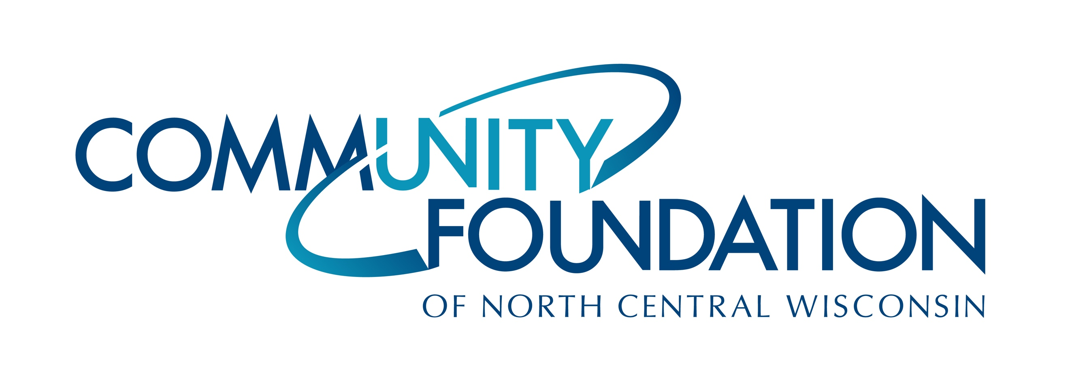
CONTACT INFORMATION:
Community Foundation of North Central Wisconsin
Sue Nelson | Program Officer
715.845.9555
sue@cfoncw.org

RELEASE DATE:
March 29, 2021

COMMUNITY FOUNDATION AWARDS $117,420 IN
COMMUNITY ENHANCEMENT GRANTS

[WAUSAU, WI, March 2021] — The Community Foundation of North Central Wisconsin announced that nine charitable causes have received Community Enhancement Grants totaling $117,420 in the first quarter of 2021.

Community Enhancement Grants address the tangible needs of nonprofit organizations and new initiatives that create a vibrant and livable community for all. These grants provide support for the arts, education, health, human services, and resource preservation – enhancing every area of life for people throughout north central Wisconsin.

“Our board is dedicated to being good stewards of the contributions that have been entrusted to us, and we couldn’t be prouder of the grants that we have made in the first three months of 2021. Being forward focused, we know these grants are going to organizations and projects that are enhancing our area each day” states Ann Werth, chair of the Community Foundation’s Distributions Committee.

The Foundation will award more than $525,000 in Community Enhancement Grants this year. The next application deadline is June 1, 2021. Historically, grants have ranged in size from $1,000 to $100,000, depending on the scope of the proposal. Applicants are strongly encouraged to speak with Foundation staff before applying. Visit here for more details.

###

About the Community Foundation of North Central Wisconsin:
Since 1987, the Community Foundation of North Central Wisconsin has been connecting the passions of philanthropists with the purposes of nonprofits for local community impact. With over 33 years serving the north central Wisconsin region, the Community Foundation leads and inspires philanthropy to enhance the quality of life for generations to come. The Community Foundation has over $79 million in current assets and prudently manages 411 funds. Through its commitment to excellence in donor investment, the Foundation received $7.3 million from donors in 2020 and distributed more than $6.8 million that same year to support nonprofits throughout our area.

Community Enhancement Grants Awarded First Three Months of 2021

Organization | Purpose | Grant Amount
Central Wisconsin Off Road Cycling Coalition | Sylvan Hill Mountain Bike Park Phase II | 15,000
Lake DuBay Lions Club | Improvements at Lake DuBay Lions Park | 21,200
Little Lions Childcare | Little Lions Child Care Playground | 10,000
LuCille Tack Center for the Arts | Theatre Equipment Project | 15,000
Mosinee School District | Mosinee Elementary School Playground | 10,000
Rise Up Central Wisconsin, Inc. | "The Healing Light" Installation of the RISE UP Women's Community mural at Whitewater Music Hall | 5,000
Town of Rib Mountain | Sandy's Bark Park Expansion - Phase II | 12,500
Village of Marathon City | Marathon Baseball / Softball Complex and Veteran's Park | 25,000
Wausau Events | Contactless Transactions / Hand Sanitizer Stations | 3,720
 |  | $ 117,420

