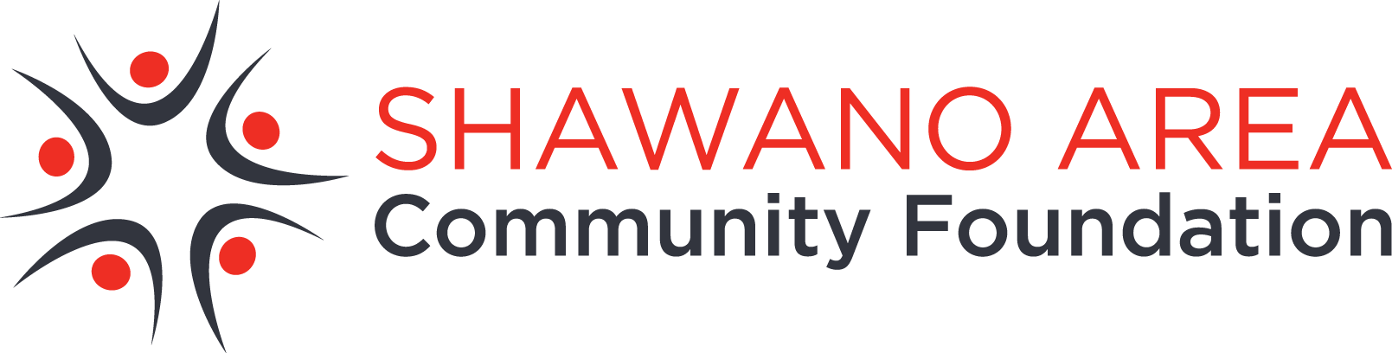

NEWS RELEASE

FOR IMMEDIATE RELEASE
April 12, 2021

For more information:
Megan Mulholland, APR
Director of marketing
Community Foundation for the Fox Valley Region
mmulholland@cffoxvalley.org
920.716.1370 Cell
$1 Million! Gresham High School Graduates
Each Can Get a $3,250 Scholarship

When the Gresham Scholarship Fund was founded 20 years ago, who would have dreamed a small tight-knit community of 565 very generous souls could grow that fund to $1 million to help their youngest pay for secondary education?

These caring, hardworking folks did it, along with help from friends, graduates, the surrounding community and the prudent investment policies of the Community Foundation for the Fox Valley Region. The funds are in the Shawano Area Community Foundation family of funds, an affiliate of the Community Foundation for the Fox Valley Region.

The scholarship amount awarded to Gresham High School graduates has increased to $3,250 – making many in the Class of 2021 eligible to receive a scholarship. The average class size is about 19. Twenty years ago, the scholarship was $400 per qualifying student and has increased steadily. To be awarded the scholarship, seniors need only to apply online and have a 2.0 grade point or better.

“These numbers are so impressive for our small school district and I thank our generous benefactors for making it possible, it’s really unbelievable,” said Alphia Creapeau, School Board President,

“As a recipient of the Gresham Scholarship, I was helped in pursuing my teaching career,” said Larissa Cerveny, Gresham kindergarten teacher. “It was a joy to know I received a scholarship along with many of my classmates. It sent a message that they wanted us to succeed in school. I decided to return to Gresham to teach because I enjoyed attending as a student. I also admired many former teachers and their examples. Like them, I hope to be an example to my students.”

Trevor Olsen, a 2012 Gresham graduate, lives in Shippensburg, Penn., where he works as a financial analyst for Schreiber Foods. He began with Schreiber Foods as an intern while attending UW-Green Bay. “The Gresham Scholarship made it an easier decision for me to attend college,” Olsen said. “It was motivating to feel the support from the close-knit Gresham community.”

Mindy Hoffman grew up on a farm along with five siblings outside of Gresham. She graduated in 2009 as class valedictorian and received a $750 scholarship from the Gresham Scholarship Fund. “I have always felt blessed to grow up in a small town, with a whole community to support my endeavors,” she said Mindy is now a DPT (Doctor of physical therapy) in Green Bay.

Its annual fundraiser, the biggest community-wide banquet of the year, has netted proceeds around $20,000 in the last few years. Denise Huntington, Fund board member said, “It’s amazing what a small caring community can do!” Her husband Dan and brother in-law Bert Huntington are the auctioneers for the event. Locals good naturedly say, “Those guys can draw blood out of a turnip” It’s true! In 2019 seven pies from the Red Rooster donated to the banquet were auctioned off for $4,650!

“Looking back 20 years, I continue to believe in the power of our community of donors,” said Bob Klopke, President and a founding board member of Gresham Scholarship Fund. “Small and large contributions have worked together to encourage our graduates and community members to reach for further education.

“I’m amazed!” added Gresham School Superintendent Newell Haffner. “This is a great little community we live in.”

If you would like to help with the second $1 million, mail a check to GSF, P.O. Box 102, Gresham, 54128. Or donate online: https://donor.cffoxvalley.org/Make-A-Gift

The Shawano Area Community Foundation was established in 1990 by and for the people of the area to improve the quality of life in Shawano and the surrounding area. It is an affiliate of the Appleton-based Community Foundation for the Fox Valley Region. To learn more, go to www.cffoxvalley.org/Shawano.

