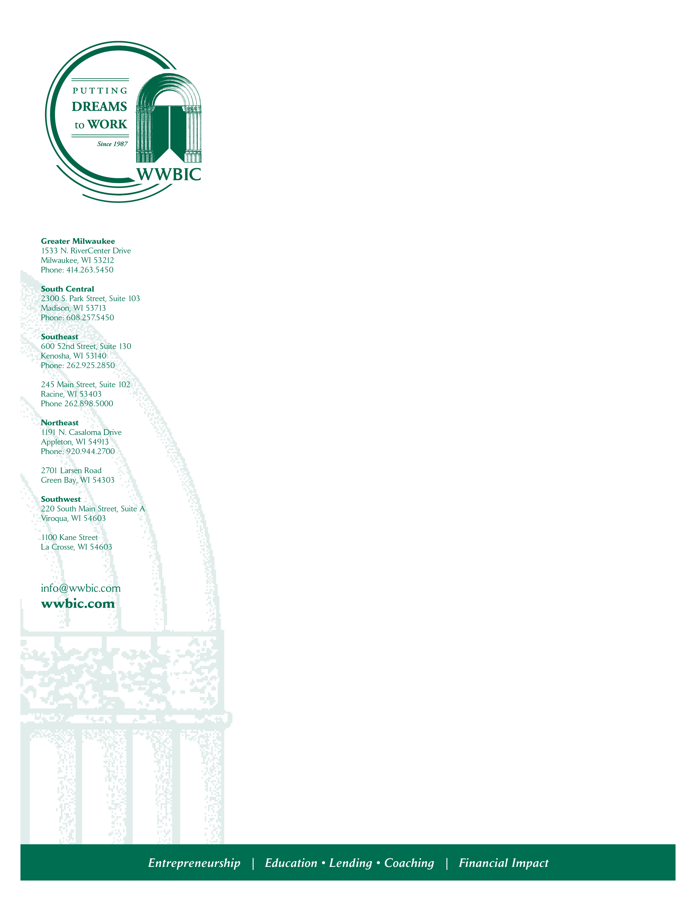
June 14. 2021

Media Contact:
Wendy Baumann, WWBIC, 414-395-4530,
wendy.baumann@wwbic.com
David Hakensen for Otto Bremer Trust, 612-840-4592, david.hakensen@hcopr.com

For Immediate Release:

Wisconsin Women’s Business Initiative Corporation Receives $500,000 Investment From Otto Bremer Trust to Support Small Businesses

PRI and Grant Will Provide Capital, Technical Assistance to Diverse and Disadvantaged Small Businesses

MILWAUKEE, June 14, 2021 – The Wisconsin Women’s Business Initiative Corporation, the state’s largest SBA microlender, has received a $500,000 investment from Otto Bremer Trust to provide responsible loan capital for diverse and disadvantaged small businesses in Wisconsin that are unable to access bank financing.

The investment includes a $400,000 program-related investment to be loaned to small business owners, supported by a $100,000 grant that will provide one-on-one technical business counseling and access to business education, networks, volunteers and other resources for those receiving loans through the program-related investment.

“We are gratified by the investment that the Otto Bremer Trust has made in WWBIC and our commitment to help entrepreneurs and small business owners in communities of color across the state,” said Wendy Baumann, President and CVO, Wisconsin Women’s Business Initiative Corporation. “These loans will impact businesses started, strengthened and expanded as well as jobs created and retained by them.”

During times of economic challenge, WWBIC has been the front line for economic development for entrepreneurs and small business owners of color. Demand for capital and business assistance took on even greater urgency during the COVID-19 pandemic and the attendant

(more)

economic and social justice crises that followed. WWBIC staff have consciously worked against structural inequities and are recognized for their expertise in effectively coaching low-income and disadvantaged target populations to successful entrepreneurship.

“WWBIC has an impressive track record of improving the well-being of individuals by advancing inclusive entrepreneurship and facilitating self-sufficiency strategies,” said Daniel Reardon, Co-CEO and Trustee, Otto Bremer Trust. “This investment will provide access to fair and responsible capital coupled with business education and technical assistance.”

About WWBIC

Wisconsin Women’s Business Initiative Corp. (WWBIC) is a leading, innovative economic development corporation “Putting Dreams to Work.” WWBIC’s primary focus is on women, people of color and low- income individuals, providing direct lending and access to fair and responsible capital, quality business education, one-on-one technical business assistance and education to increase financial capability. Since 1987, WWBIC has lent over $82 million in micro and small business loans with a current loan portfolio of $23.5 million and over 564 active borrowers. To learn more about WWBIC visit: www.wwbic.com

About the Otto Bremer Trust

The Otto Bremer Trust is a bank holding company and a private charitable trust based in Saint Paul, Minn., that works at the intersection of finance and philanthropy. Created in 1944 by Otto Bremer, it is today one of the nation’s largest philanthropic organizations and is committed to supporting a better quality of life for residents of Minnesota, Montana, North Dakota, and Wisconsin. OBT is the majority owner of Bremer Financial Corporation, a regional financial services company; manages a diversified investment portfolio; and operates Community Benefit Financial Company, a financial resources subsidiary. Since its founding, OBT has invested more than $841 million in people, places, and opportunities in the Upper Midwest. Visit ottobremer.org.
# # #


Begin typing message here.

