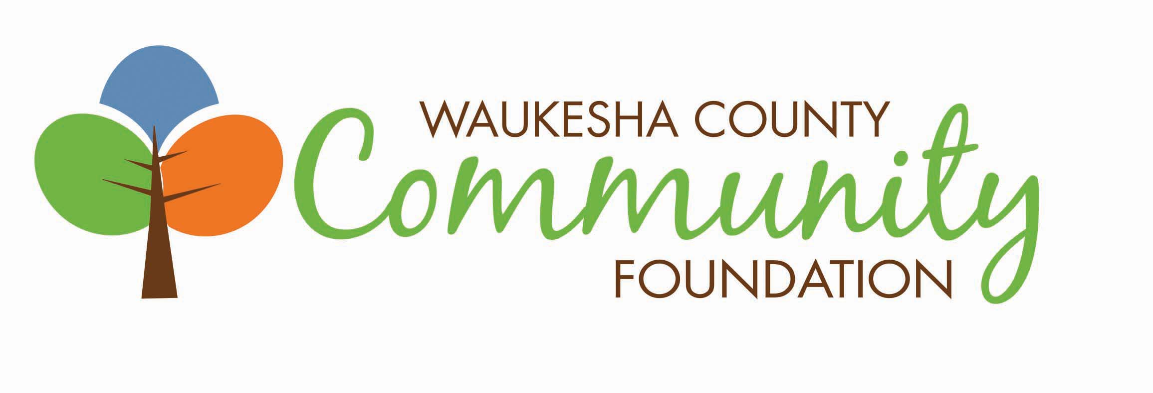

Position: President
Classification: Full Time
Supervisor: Chairman Foundation Board of Directors

Mission and Organization
The Waukesha County Community Foundation is a pool of permanent endowment and project funds created primarily by and for the people of Waukesha County to provide grant support to charitable organizations. The intent of the Foundation is to serve a broad spectrum of community needs. Waukesha County Community Foundation was founded in 1999, maintains $67 million in assets, and is governed by a 25-member Board of Directors. For more information, please visit www.waukeshafoundation.org.

Core Values and Culture
Waukesha County Community Foundation staff and Board are committed to core values of equity, collaboration, community, generosity, and transparency. The Community Foundation has a community-centric approach in its grantmaking and is known by donors and partners for being a trusted, professional, and visionary organization. The passionate and expert staff value working in partnership to engage the community in making Waukesha County a wonderful place to live, work, and play for the whole community.

Diversity, Equity, & Inclusion
The Community Foundation is committed to the advancement of diversity, equity, and inclusion, and we strive to make Waukesha County a place where all people can fully realize their aspirations.

Position Profile

The President will be responsible for all operations of the Foundation to assure achievement of its mission, financial viability and long-term growth and stability. The top priority is to build and manage Foundation relationships with the goal of increasing the Foundation’s philanthropic assets.

Position Responsibilities
Responsibilities include building Foundation relationships; attracting funds; administration and governance; grants programming and community leadership.

Relationship Building
- Strengthen the Foundation’s relationships with its constituents and represent the Foundation to critical donor, nonprofit, professional advisor, civic and governmental contacts.
- Integrate donor interests with community needs and assure donor satisfaction.
- Plan and implement donor recognition activities.

Fund Development
- Provide leadership for all Foundation asset development activities.
- Engage directors and other volunteers to attract contributions for new and existing funds.
- Promote current and future contributions; develop and manage plans to identify and contact potential donors.
- Communicate to potential donors through development of printed materials, newsletters, website, social media, face-to-face visits, and public presentations.

Administration and Governance
- Provide team leadership, integrating and coordinating all segments of the organization to achieve optimum results.
- Motivate staff for high productivity and to achieve desired results.
- Lead the strategic planning process, in conjunction with the Board of Directors, to develop short and long-term plans, goals and objectives.
- Keep Board advised of overall operations. Serve as a staff advisor to all Board committees.
- Insure accurate Board and committee agendas and meeting minutes.
- Manage the Foundation’s operating budget.
- Assure that the Foundation conforms to all related laws and regulations and standards of the community foundation field.
- Maintain state-of-the art knowledge of the community foundation and philanthropy field.

Grants Programming and Community Leadership
- Optimize discretionary grant funds to address community needs.
- Inform advisors of donor advised funds about community needs and grant opportunities.
- Provide leadership in determining community problems; identify opportunities; employ the resources of the Foundation and its leaders to address them.
- Serve as an advocate for the Foundation and community philanthropy. Participate in appropriate local, regional and national organizations.

Desirable Qualifications
- 7+ years of experience of nonprofit, private, and/or public executive leadership experience with proven ability to effectively manage and lead a growth-oriented organization.
- Broad, general knowledge of planning, finance and investments, budgeting and human resource management.
- Familiarity with charitable giving methods.
- Demonstrated understanding of community foundations/community philanthropy.
- Understanding of the economic, cultural and social environment of Southeastern Wisconsin, including knowledge of nonprofit sector preferred.
- Strong management and team leadership skills.
- Exceptional written and oral communication skills; stand-up presentation skills.
- High level of interpersonal competency; demonstrated ability to build and maintain relationships based on high levels of trust and integrity.
- Demonstrated ability and passion to fundraise.
- Ability to work under pressure and to meet deadlines.
- Commitment to diversity, equity, and inclusion.
- Ability to maintain strict confidence and exhibit professionalism.

Compensation
Salary will be commensurate with the experience of candidate and norms in the field. The position includes health and dental benefits, as well as, paid vacation.

Application Process
To inquire or apply for this position, contact Shelli Marquardt at smarquardt@waukeshafoundation.org

