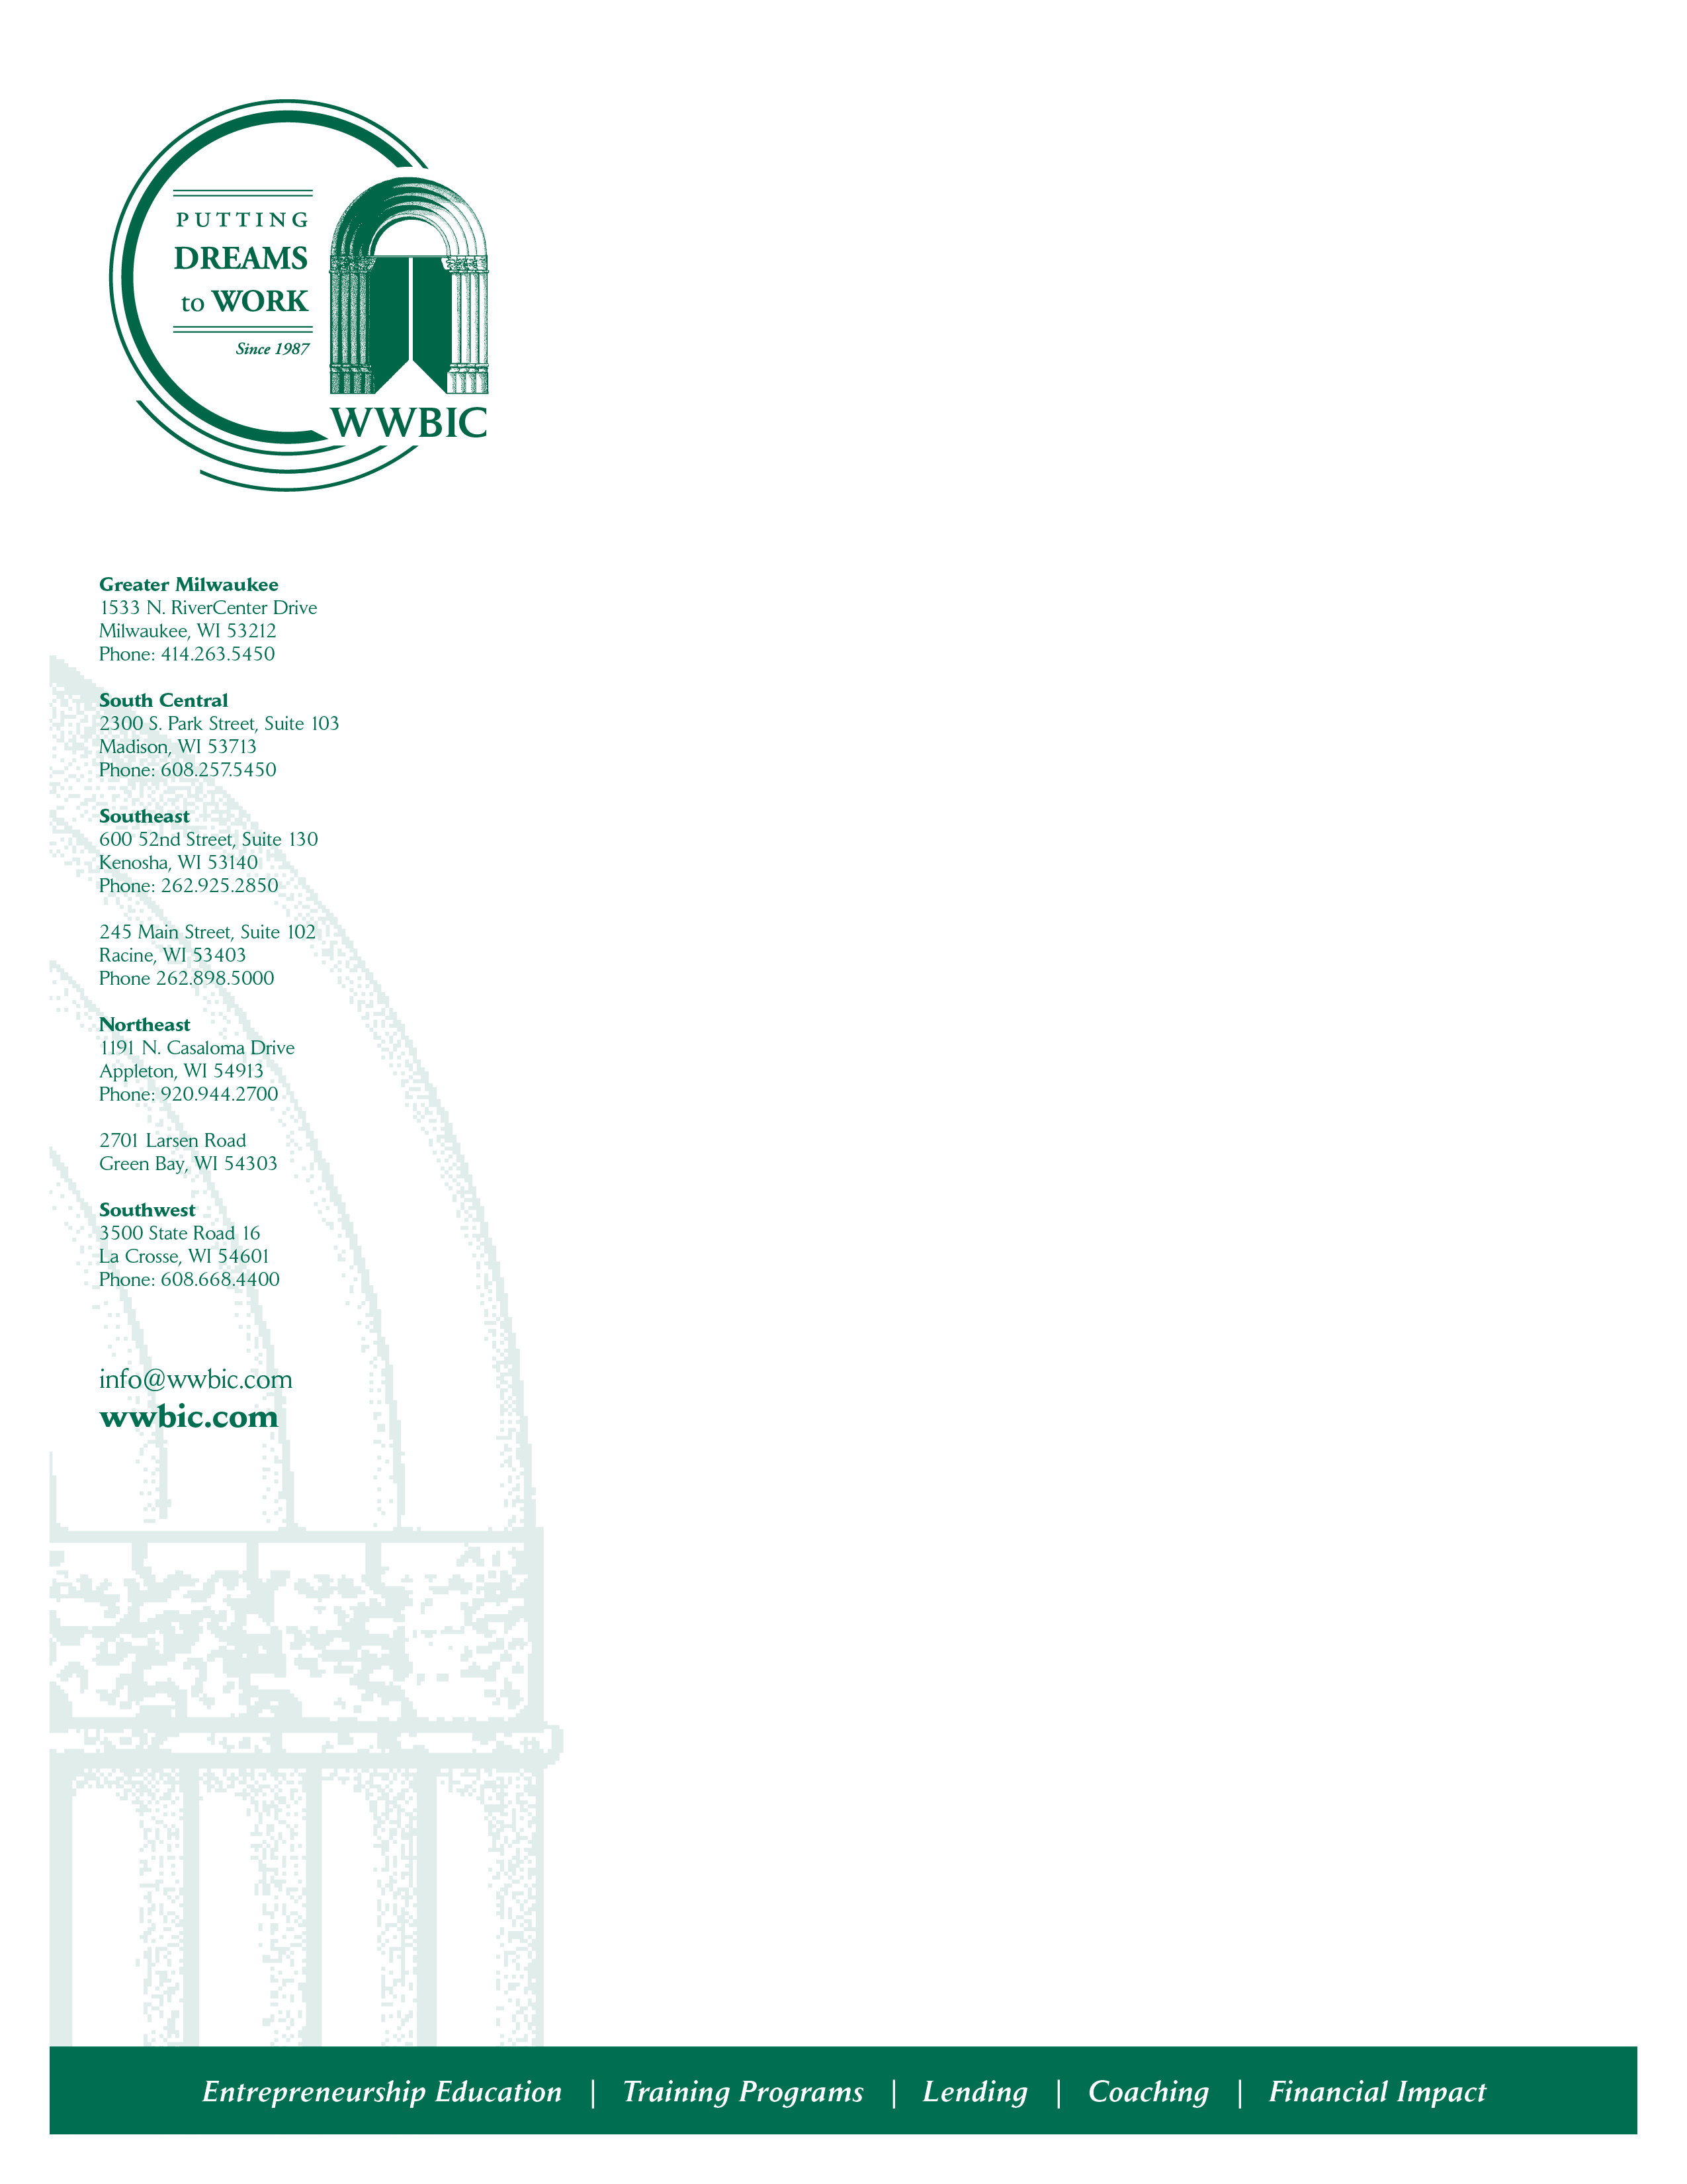
WWBIC is a CDFI organization that has served 68,516 clients since its inception almost 35 years ago. Since our incorporation in 1987, we have also loaned more than $82 million to small business borrowers, and helped entrepreneurs create and retain 12,538 jobs. In 2020 alone WWBIC closed $6,380,117 in small business loans which includes WWBIC loans ($4,327,250), the SBA Payment Protection Program (PPP) ($1,628,267), and Community Block Development Block Grant (CDBG) forgivable loans ($424,600) with millions still in our pipeline for support in 2021. We remain central to the small business recovery and restart here in Wisconsin by supporting micro and small businesses in our local communities and throughout the state – those creating jobs and employment while providing needed products and services.

We are currently recruiting for an individual to support our mission in the following capacity.

Bilingual Loan Officer - Milwaukee

This full time position is responsible for producing approved, closed and disbursed business loans and for expansion of WWBIC’s micro lending programs with a focus on Hispanic, bi-lingual and Spanish-speaking clients. Core responsibilities include: Identify, analyze, underwrite and close loan applications, develop and foster key relationships to ensure collaborative partnerships with area financial institutions and other sources for loan referrals, maintain a presence in the community to facilitate loan production, represent WWBIC at community and professional functions, conferences and meetings and maintain on going loan client contact.

This position requires a genuine desire to work with business owners of diverse ethnic and socio-economic backgrounds. Bachelor’s degree, at least 5 years solid work experience in commercial banking or underwriting, strong analytical and organization skills, the ability to multitask and meet deadlines and strong communication skills and Spanish-language fluency are required. Must have valid drivers license and proof of insurance as position requires local travel. Experience in small business financing or community development lending is preferred.

The salary is competitive, depending on qualifications. Benefits include health and dental coverage, 403(b) savings plan and more in a family-friendly environment. To apply, please email a letter of application, resume & salary requirements to jobs@wwbic.com.

Equal Opportunity Employer

