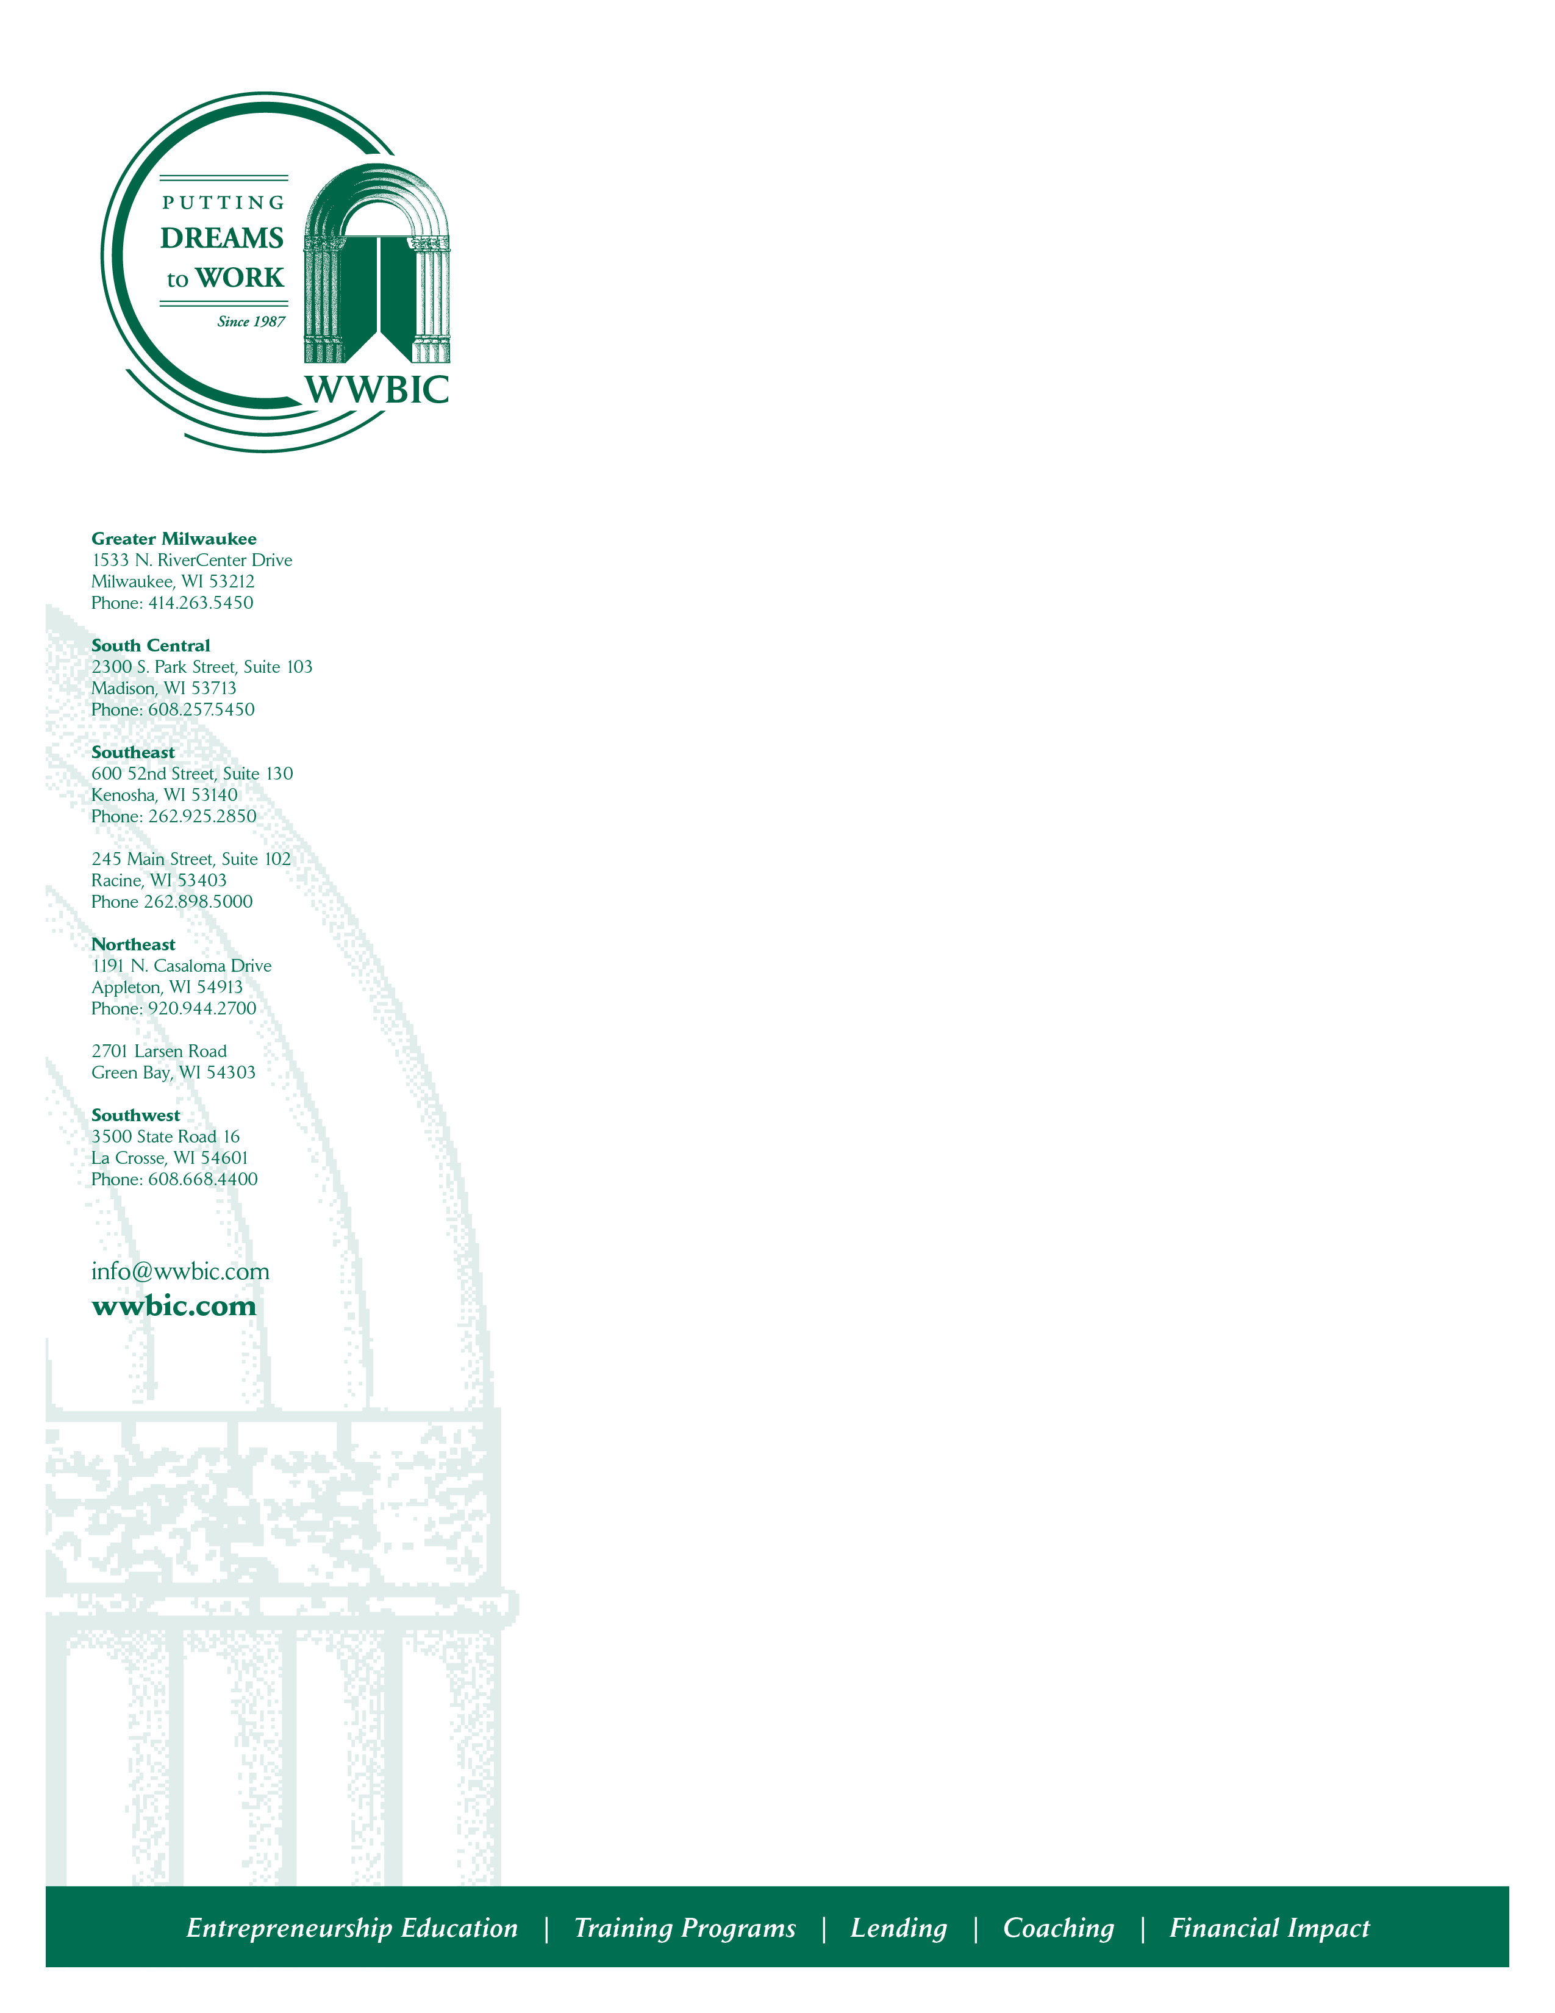

WWBIC is a CDFI organization that has served 68,516 clients since its inception almost 35 years ago. Since our incorporation in 1987, we have also loaned more than $82 million to small business borrowers, and helped entrepreneurs create and retain 12,538 jobs. In 2020 alone WWBIC closed $6,380,117 in small business loans which includes WWBIC loans ($4,327,250), the SBA Payment Protection Program (PPP) ($1,628,267), and Community Block Development Block Grant (CDBG) forgivable loans ($424,600) with millions still in our pipeline for support in 2021. We remain central to the small business recovery and restart here in Wisconsin by supporting micro and small businesses in our local communities and throughout the state – those creating jobs and employment while providing needed products and services.

We are currently recruiting for an individual to support our mission in the following capacity.
Small Business Consultant – Racine/Kenosha, WI
This position is responsible for delivery and coordination of WWBIC’s business assistance programs. Core responsibilities include: assessing client needs and providing direct one-on-one or small group technical assistance and counseling to WWBIC loan clients; conducting business site visits; promoting awareness of client businesses; performing comprehensive review of business plans including marketing, financial goals, financial statements, and projections; developing action plans to achieve goals and monitoring progress; and assisting clients in creating cash flow projections and financial analysis for guidance in making decisions.
This position requires a genuine desire to work with small business owners of diverse ethnic and socio-economic backgrounds. Some travel and evening/weekend hours required. Bachelor’s degree or equivalent experience, 3-5 years solid work experience, preferably in small business planning, business development, or business counseling and strong communication skills and professionalism is required. Having been a small business owner previously is preferred.
The salary is competitive, depending on qualifications. Benefits include health and dental coverage, 403(b) savings plan and more in a family-friendly environment. To apply, please email a letter of application, resume & salary requirements to jobs@wwbic.com.

Equal Opportunity Employer

