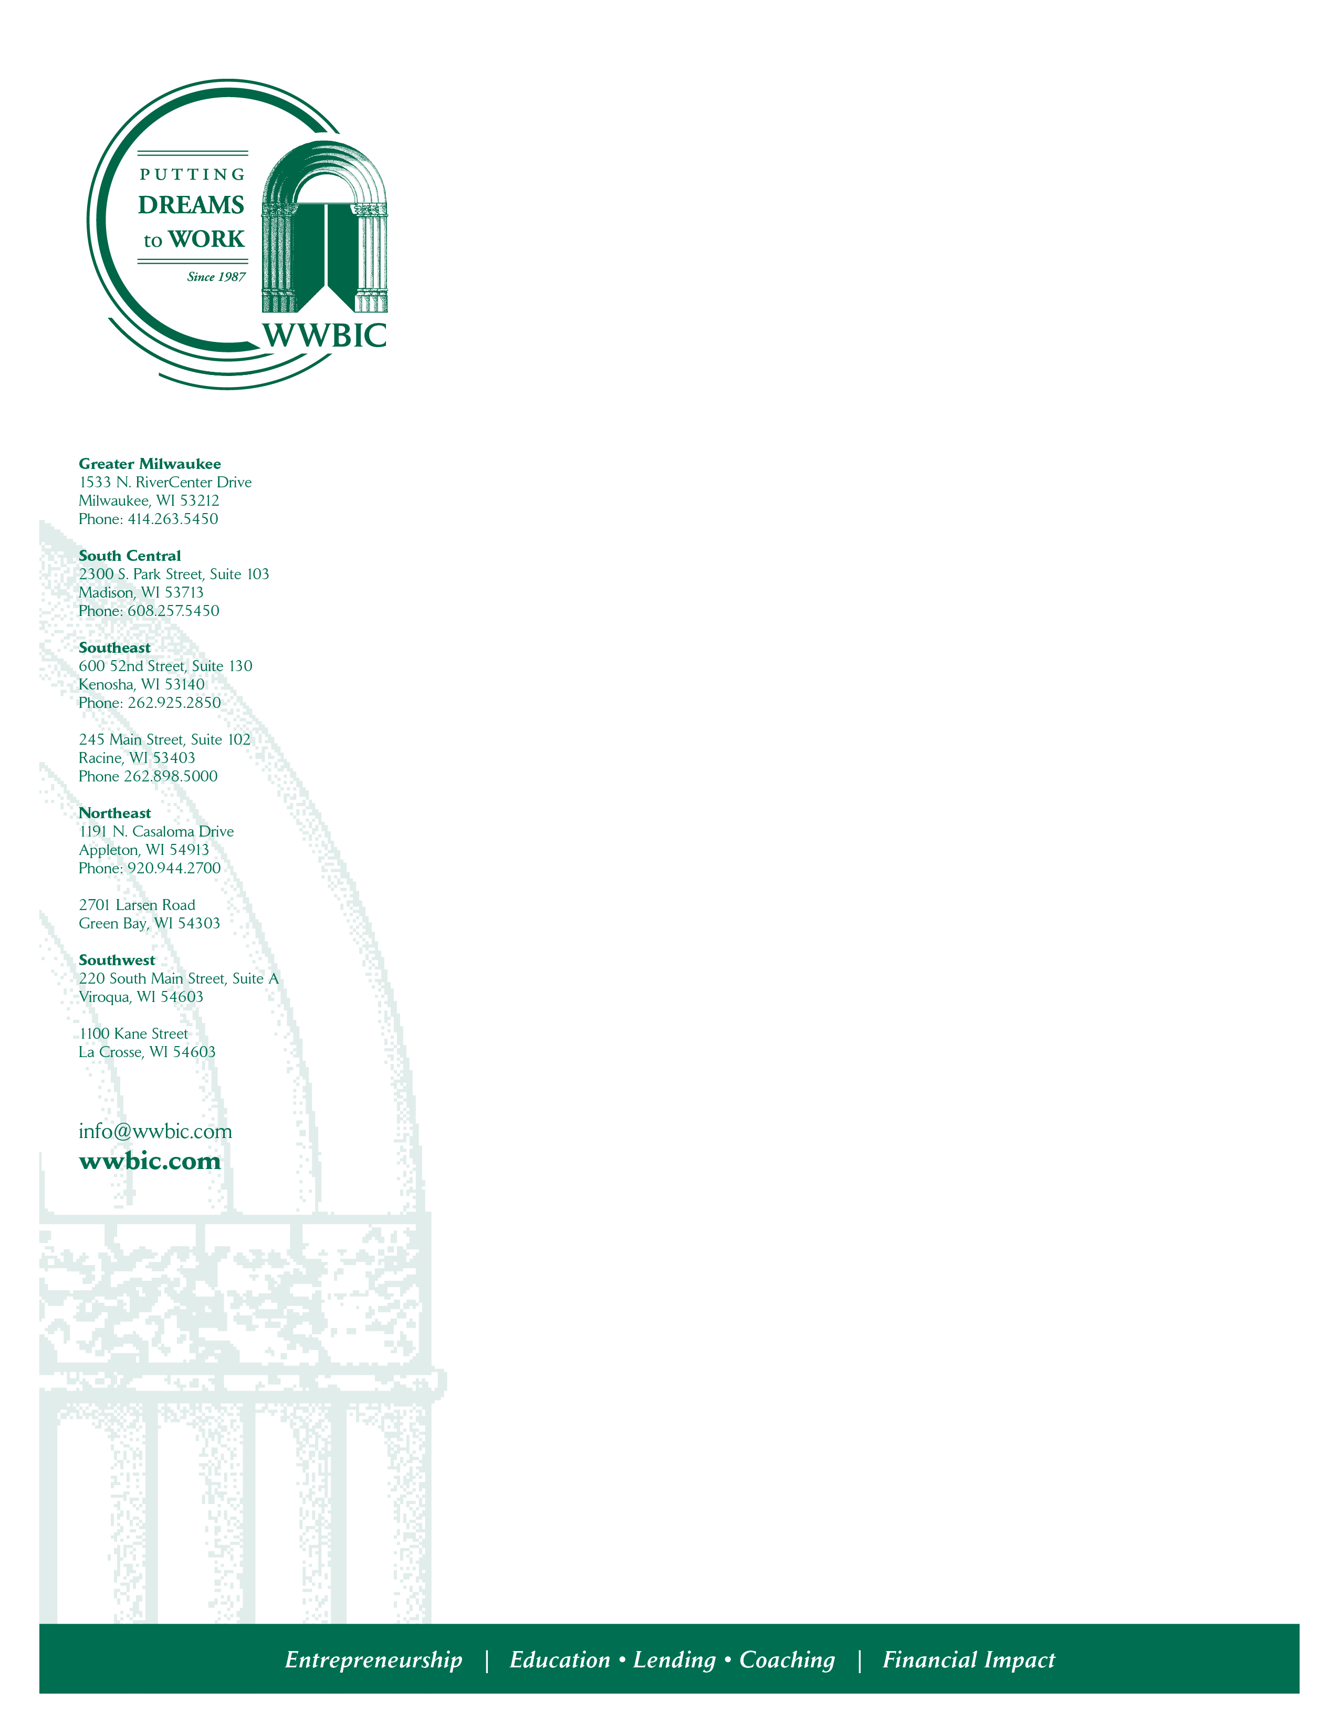

WWBIC is a CDFI organization that has served 68,516 clients since its inception almost 35 years ago. Since our incorporation in 1987, we have also loaned more than $82 million to small business borrowers, and helped entrepreneurs create and retain 12,538 jobs. In 2020 alone WWBIC closed $6,380,117 in small business loans which includes WWBIC loans ($4,327,250), the SBA Payment Protection Program (PPP) ($1,628,267), and Community Block Development Block Grant (CDBG) forgivable loans ($424,600) with millions still in our pipeline for support in 2021. We remain central to the small business recovery and restart here in Wisconsin by supporting micro and small businesses in our local communities and throughout the state – those creating jobs and employment while providing needed products and services.

We are currently recruiting for an individual to support our mission in the following capacity.

Associate Director, Grants & Compliance – Milwaukee, WI

This full-time position is responsible for supporting development efforts and managing all post-award grant/contract compliance and reporting requirements related to external funding sources and internal outcomes management. Core responsibilities include: managing and preparing funder-required tracking and compliance reports; evaluating funder and grant contracts for requirements and timelines; coordinating with staff to ensure deliverables and metrics are clear and regularly provided; manage and develop relationshps with WWBIC’s diverse funding sources and work closely with Director of Development in completing assigned proposals.

A Bachelor’s degree or equivalent experience, along with 3-5 years related work experience and proficiency in Microsoft Office, Outlook, Excel, and PDFs is required. In addition, excellent organizational skills, attention to detail, the ability to work under pressure and meet deadlines are needed. Must possess strong verbal and written communication skills and the ability to work with diverse audiences. Previous supervisory experience preferred. Knowledge of microenterprise, social enterprise and/or community economic development issues preferred but not required

Benefits include health and dental coverage, 403(b) savings plan and more in a family-friendly environment. To apply, please email a letter of application, resume & salary requirements to jobs@wwbic.com.

Equal Opportunity Employer

