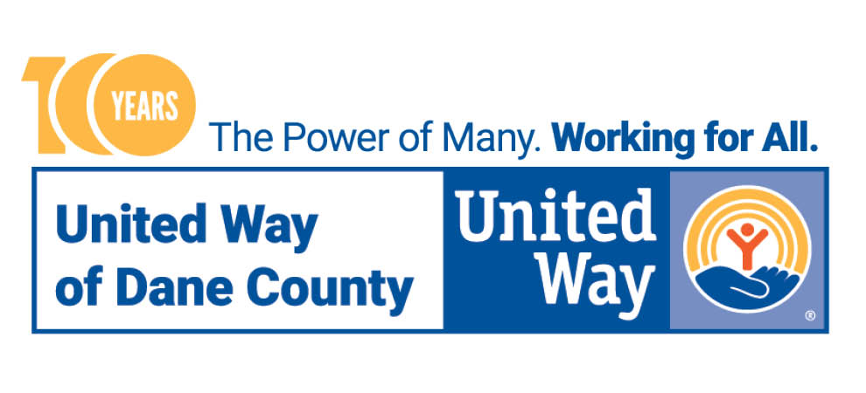

UNITED WAY 211 SEEKING APPLICANTS FOR VIRTUAL RESOURCE SPECIALIST THROUGH AMERICORPS PROGRAM

Madison, WI (July 13, 2022) – United Way’s 211 helpline is the most comprehensive health and human services database in all of Dane County. Our staff and volunteers are available to offer free, confidential assistance to neighbors in need, 24/7. And we’re seeking a Virtual Resource Specialist to join our team!

The person hired into this position would be working in our 211 call center virtually, with the main task of connecting community members who are in need of AODA, mental health supports or other needs with available resources. This position is funded through our partners at AmeriCorps, and the year-long service term is 9/12/2022-8/31/2023. The selected candidate will be given a weekly living allowance, basic health insurance, mileage reimbursement, subsidized childcare and be awarded with a $6,495 Education Award Student Loan Forbearance that can help pay for college, graduate school or vocational training, or to repay student loans.

“I started at 211 hoping to make an impact in my community during the pandemic,” says Mario Fregoso, current 211 Resource Specialist through the AmeriCorps program. “What I realized is there was so much more going on in our communities and that many other crises have been taking place that often are not brought to our attention. Through this job, I know every day that I’m making a difference by speaking directly to the community and giving them the tools to face the many issues we continue to see in Wisconsin.”

To learn more and apply, please visit https://www.unitedwaydanecounty.org/about-us/careers/americorps/.

